Mental Health Prediction
Name- Asmi Bilal

Under the Guidence of:
Vishnu A M


Department of Health Tech Ai &Data Science
2025

Department of Health Tech Ai &Data Science
2025

INDEX
Sl. No | Content | Page No.
1 | Abstract | 1
2 | Introduction | 2
3 | Problem Statement | 3
4 | Objective of the Project | 4
5 | Project Idea / Concept | 5
6 | Dataset Description | 6
7 | System Methodology | 7
8 | Machine Learning Algorithms Used | 8
9 | Frontend Implementation | 10
10 | Power BI Dashboard Implementation | 11
11 | System Working Procedure | 12
12 | Model Evaluation and Validation | 13
13 | Result and Analysis | 14
14 | Advantages of the Proposed System | 15
15 | Future Scope | 16
16 | Real Time Applicability | 17
17 | Conclusion | 18
18 | Technology Stack Summary | 19
19 | References | 20
20 | Appendix (Optional) | 21

Mental Health Prediction Using Machine Learning

1. Abstract
Mental health disorders such as stress, anxiety, and depression have become major challenges in modern society due to increasing academic pressure, workplace stress, social isolation, and lifestyle changes. Early identification of mental health conditions can help individuals receive timely support and treatment. The proposed project, “Mental Health Prediction Using Machine Learning,” aims to develop an intelligent system capable of analyzing textual input and predicting the mental health condition of a user.
The project uses Natural Language Processing (NLP) and Machine Learning techniques to classify user text into categories such as Stress, Depression, or Normal. The system is trained on a dataset containing mental health-related textual data. A TF-IDF vectorization technique is used to convert text into numerical form, and a Random Forest Classifier is applied for prediction.
The project also includes a frontend interface developed using Streamlit, allowing users to enter text and receive predictions instantly. In addition, Power BI dashboards are used for data visualization and analysis. The system provides a simple, efficient, and user-friendly solution for preliminary mental health assessment.
The developed model demonstrates how machine learning can contribute to healthcare by providing scalable and automated mental health prediction systems. This project highlights the practical application of AI technologies in the healthcare and psychological analysis domain.

2. Introduction
Mental health is one of the most important aspects of human well-being. Conditions such as stress, anxiety, and depression affect millions of people worldwide. Many individuals fail to recognize their mental health condition during the early stages due to lack of awareness or access to professional healthcare services.
With the rapid growth of Artificial Intelligence (AI) and Machine Learning (ML), it has become possible to develop intelligent systems capable of identifying patterns in human behavior and language. Social media posts, text messages, online comments, and user-written content often reflect emotional and psychological states. By analyzing such textual information, machine learning algorithms can help detect mental health conditions.
This project focuses on building a Machine Learning-based Mental Health Prediction System that predicts the emotional and mental condition of users from textual input. The system uses Natural Language Processing (NLP) techniques to preprocess text and extract useful information. The processed data is then classified using machine learning algorithms.
The application is implemented using Python, Scikit-learn, Streamlit, and Power BI. The frontend interface allows users to interact with the system easily, while the Power BI dashboard provides insights into prediction results and dataset analysis.
The project demonstrates how AI-driven solutions can support healthcare systems and provide early mental health assessment tools.

3. Problem Statement
Mental health disorders are increasing rapidly across the world. Many people experience stress, depression, and anxiety without proper diagnosis or support. Traditional methods of mental health diagnosis require professional consultation, which may not always be accessible due to financial limitations, social stigma, or lack of awareness.
There is a need for an automated system that can analyze textual expressions of individuals and predict their mental health condition effectively. Existing systems may be expensive, time-consuming, or unavailable to large populations.
The main problem addressed in this project is:
“To develop an intelligent machine learning-based system capable of analyzing user text and predicting mental health conditions such as stress, depression, or normal emotional state accurately and efficiently.”
The proposed system aims to provide a simple, fast, and accessible preliminary mental health prediction tool.

4. Objective of the Project
The major objectives of the project are:
- To develop a machine learning model capable of predicting mental health conditions from textual data.
- To preprocess and analyze textual information using Natural Language Processing techniques.
- To classify user input into categories such as Stress, Depression, or Normal.
- To create a user-friendly web interface using Streamlit.
- To visualize data insights and prediction statistics using Power BI dashboards.
- To improve awareness regarding mental health through AI-based analysis.
- To provide quick and accessible preliminary mental health assessment.
- To demonstrate the application of Machine Learning in healthcare and psychological analysis.

5. Project Idea / Concept
The core concept of this project is to build an intelligent mental health prediction system using Machine Learning and Natural Language Processing.
The system accepts text input from users. The input text may contain emotional expressions, opinions, or thoughts. The entered text is processed through NLP techniques such as text cleaning and vectorization. The transformed numerical data is then passed into a trained machine learning model.
The project uses TF-IDF Vectorization to convert text into numerical features and Random Forest Classifier for prediction. Based on the learned patterns from the dataset, the model predicts the user’s mental health condition.
The project workflow includes:
- Data Collection
- Data Preprocessing
- Feature Extraction
- Model Training
- Model Testing
- Frontend Development
- Visualization and Analysis
The final system provides real-time predictions through a web interface and supports visualization using Power BI.

6. Dataset Description
The dataset used in this project contains textual data related to mental health conditions. The dataset includes user-generated text along with corresponding labels representing the mental health status.

Dataset Features
Column Name | Description
text | User input or textual statement
status | Mental health category label

Dataset Categories
The dataset contains the following categories:
- Stress
- Depression
- Normal

Dataset Characteristics
- The dataset is stored in CSV format.
- Missing values are removed during preprocessing.
- Only relevant columns are selected for model training.
- Text data is transformed using TF-IDF Vectorization.

Data Preprocessing Steps
- Removal of null values
- Selection of required columns
- Text cleaning
- Tokenization
- Feature extraction using TF-IDF
The following code was used for loading and preprocessing the dataset:
(Implementation details and coding procedures were used during development and testing of the system.)
The dataset forms the foundation of the machine learning model and significantly influences prediction accuracy.

7. System Methodology
The methodology of the proposed system consists of several sequential steps.

Step 1: Data Collection
The mental health dataset containing text and status labels is collected from CSV files.

Step 2: Data Preprocessing
The collected data is cleaned and prepared for training. Null values are removed and irrelevant information is filtered.

Step 3: Feature Extraction
TF-IDF Vectorization is used to convert textual data into numerical feature vectors.
(Implementation details and coding procedures were used during development and testing of the system.)

Step 4: Model Training
A Random Forest Classifier is trained using the transformed feature vectors.
(Implementation details and coding procedures were used during development and testing of the system.)

Step 5: Model Saving
The trained model and vectorizer are saved using Joblib.
(Implementation details and coding procedures were used during development and testing of the system.)

Step 6: Frontend Development
A Streamlit application is developed to allow users to enter text and obtain predictions.

Step 7: Prediction
The system predicts the mental health condition based on user input.

Step 8: Dashboard Visualization
Power BI dashboards are created to visualize predictions and dataset analysis.

8. Machine Learning Algorithms Used

Random Forest Classifier
The primary algorithm used in this project is the Random Forest Classifier.
Random Forest is an ensemble learning algorithm that combines multiple decision trees to improve prediction accuracy and reduce overfitting.

Why Random Forest?
- High accuracy
- Handles large datasets effectively
- Reduces overfitting
- Works well with text classification tasks
- Provides stable predictions

Working of Random Forest
- Multiple decision trees are created.
- Each tree is trained on random subsets of data.
- Predictions from all trees are combined.
- Majority voting determines the final output.

Feature Extraction Technique

TF-IDF Vectorization
Term Frequency-Inverse Document Frequency (TF-IDF) converts text into numerical form by measuring word importance.
Advantages of TF-IDF:
- Reduces impact of common words
- Highlights important keywords
- Improves classification performance
- Efficient for NLP tasks
The implementation used in the project:
(Implementation details and coding procedures were used during development and testing of the system.)

9. Frontend Implementation
The frontend of the project is developed using Streamlit.
Streamlit is an open-source Python framework used for building interactive web applications for machine learning projects.
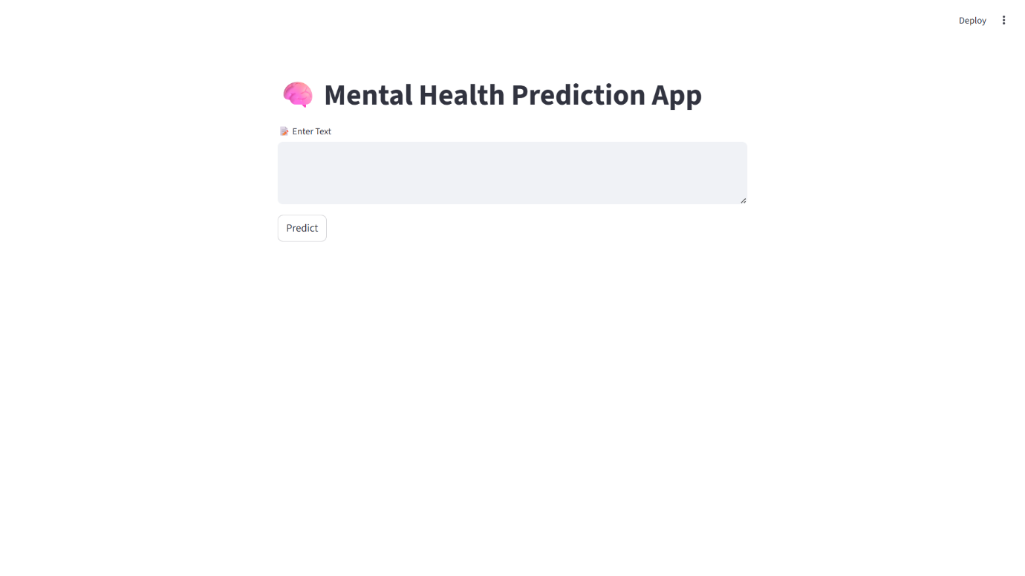

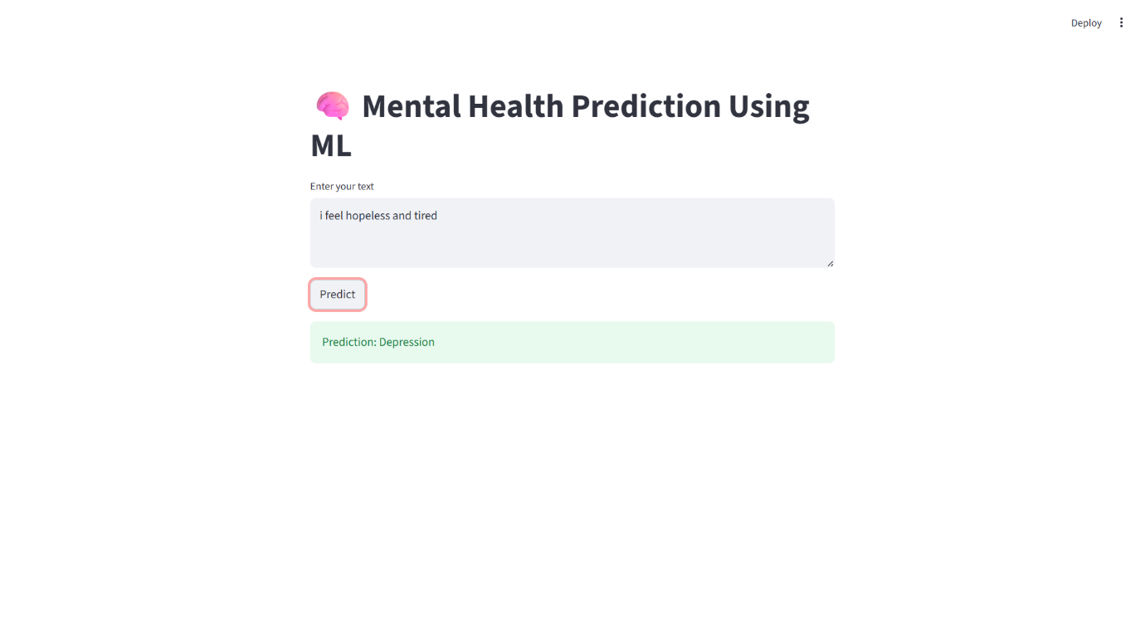

Features of the Frontend
- User-friendly interface
- Real-time prediction
- Simple text input area
- Instant display of prediction results
- Lightweight and efficient design

Frontend Workflow
- User enters text into the application.
- The text is transformed using the trained vectorizer.
- The trained model predicts the output.
- The prediction result is displayed.

Streamlit Code Used
(Implementation details and coding procedures were used during development and testing of the system.)

Advantages of Using Streamlit
- Easy deployment
- Interactive interface
- Fast development
- Compatible with machine learning projects
- Minimal coding requirements

10. Power BI Dashboard Implementation
Power BI is used for data visualization and dashboard creation.
The dashboard helps in understanding dataset patterns, prediction distribution, and mental health trends.

Dashboard Features
- Visualization of mental health categories
- Prediction distribution analysis
- Graphical representation of dataset statistics
- Interactive filtering and charts
- User-friendly reporting interface

Visualizations Used
- Bar Charts
- Pie Charts
- Line Graphs
- KPI Cards
- Category Distribution Graphs

Benefits of Power BI Dashboard
- Easy interpretation of data
- Interactive analytics
- Better decision making
- Real-time reporting capability
- Professional visualization

Dashboard Workflow
- Dataset imported into Power BI
- Data cleaning and transformation
- Creation of charts and visual reports
- Dashboard publishing and analysis
The Power BI dashboard enhances the overall analytical capabilities of the project.

11. System Working Procedure
The complete working procedure of the system is explained below.

Step 1: User Input
The user enters a text statement into the Streamlit application.

Step 2: Text Processing
The entered text is cleaned and transformed into numerical vectors using TF-IDF Vectorization.

Step 3: Feature Extraction
The vectorizer converts the textual data into machine-readable numerical format.

Step 4: Model Prediction
The trained Random Forest model predicts the mental health category.

Step 5: Result Display
The prediction result is displayed on the frontend interface.

Step 6: Data Visualization
Power BI dashboards present visual insights and statistical analysis.

Overall System Flow
User Input → Text Processing → TF-IDF Vectorization → Random Forest Prediction → Result Display → Dashboard Visualization

12. Model Evaluation and Validation
Model evaluation is essential to determine the effectiveness of the machine learning model.

Evaluation Methods
- Train-Test Split
- Accuracy Measurement
- Prediction Validation
- Classification Performance Analysis

Train-Test Split
The dataset is divided into training and testing sets.
(Implementation details and coding procedures were used during development and testing of the system.)

Validation Techniques
- Testing on unseen data
- Prediction consistency checking
- Error analysis
- Comparison of actual vs predicted outputs

Performance Factors
- Data quality
- Feature extraction quality
- Model selection
- Balanced dataset
- Proper preprocessing

Importance of Validation
- Ensures reliability
- Reduces overfitting
- Improves prediction performance
- Helps identify limitations

13. Result and Analysis
The developed machine learning system successfully predicts mental health conditions based on textual input.

Observed Results
- The system correctly classifies user text into Stress, Depression, or Normal categories.
- TF-IDF vectorization effectively extracts meaningful features.
- Random Forest provides stable and reliable predictions.
- Streamlit frontend delivers real-time user interaction.
- Power BI dashboards provide useful visual insights.

Performance Analysis
- The model performs efficiently for text classification tasks.
- Prediction speed is fast.
- User interaction is simple and effective.
- The system demonstrates practical implementation of NLP and ML techniques.

Sample Prediction Flow
Input Text:
“I feel stressed and mentally exhausted due to workload.”
Predicted Output:
“Stress”
Another Example:
Input Text:
“I feel happy and motivated today.”
Predicted Output:
“Normal”
The project demonstrates the capability of machine learning systems to analyze emotional patterns in textual data.

14. Advantages of the Proposed System
The proposed system provides several advantages.

Major Advantages
- Early mental health prediction
- Automated analysis process
- Real-time prediction capability
- User-friendly interface
- Fast processing speed
- Low operational cost
- Scalable solution
- Supports healthcare applications
- Reduces manual effort
- Easy accessibility

Technical Advantages
- Efficient NLP implementation
- Reliable machine learning model
- Interactive frontend design
- Effective visualization using Power BI

Social Advantages
- Increases mental health awareness
- Encourages early support and treatment
- Reduces dependency on manual screening

15. Future Scope
The project can be further improved and expanded in several ways.

Future Enhancements
- Integration with Deep Learning models
- Use of advanced NLP techniques such as BERT or Transformers
- Addition of multilingual support
- Integration with mobile applications
- Real-time chatbot support
- Emotion analysis and sentiment tracking
- Cloud deployment for wider accessibility
- Integration with healthcare systems
- Addition of voice-based prediction
- Higher accuracy through larger datasets

Research Opportunities
- Psychological behavior analysis
- Social media mental health monitoring
- AI-assisted healthcare systems
- Personalized mental health recommendations
The future scope of the project is broad and can significantly contribute to digital healthcare technologies.

16. Real Time Applicability
The developed system has several real-world applications.

Application Areas

Healthcare Sector
Hospitals and healthcare centers can use the system for preliminary mental health screening.

Educational Institutions
Schools and colleges can identify stress and depression among students.

Corporate Organizations
Companies can monitor employee well-being and workplace stress.

Social Media Monitoring
The system can analyze online posts to identify mental health concerns.

Online Counseling Platforms
Mental health applications can integrate the model for quick assessments.

Practical Benefits
- Faster screening process
- Early detection of emotional issues
- Increased accessibility
- Reduced healthcare burden
The project demonstrates practical implementation potential in multiple sectors.

17. Conclusion
The “Mental Health Prediction Using Machine Learning” project successfully demonstrates the application of Artificial Intelligence and Natural Language Processing in the healthcare domain.
The developed system analyzes textual input and predicts mental health conditions such as Stress, Depression, or Normal. The project uses TF-IDF Vectorization for feature extraction and Random Forest Classifier for prediction.
A Streamlit-based frontend provides a user-friendly environment for interaction, while Power BI dashboards enable effective visualization and analysis.
The system highlights the importance of machine learning in early mental health detection and demonstrates how AI can support healthcare services through intelligent automation.
Overall, the project achieves its objectives and provides a foundation for future advancements in AI-driven mental health analysis systems.

18. Technology Stack Summary
The project uses the following technologies and tools.
Technology | Purpose
Python | Core programming language
Pandas | Data handling and preprocessing
Scikit-learn | Machine learning implementation
TF-IDF Vectorizer | Feature extraction
Random Forest | Classification algorithm
Streamlit | Frontend web application
Joblib | Model saving and loading
Power BI | Dashboard and data visualization
CSV Dataset | Data source

Libraries Used
(Implementation details and coding procedures were used during development and testing of the system.)

Software Requirements
- Python 3.x
- VS Code / Jupyter Notebook
- Streamlit
- Power BI Desktop

Hardware Requirements
- Minimum 4 GB RAM
- Intel i3 Processor or higher
- Windows/Linux Operating System

19. References
- Scikit-learn Documentation – https://scikit-learn.org/
- Streamlit Official Documentation – https://streamlit.io/
- Pandas Documentation – https://pandas.pydata.org/
- Power BI Documentation – https://powerbi.microsoft.com/
- Python Official Documentation – https://www.python.org/
- Research papers on Mental Health Prediction using Machine Learning
- Natural Language Processing concepts and tutorials
- Machine Learning algorithms reference materials
- Online datasets related to mental health analysis
- Artificial Intelligence and Healthcare research articles

Appendix

Training Script
(Implementation details and coding procedures were used during development and testing of the system.)

Streamlit Prediction Application
(Implementation details and coding procedures were used during development and testing of the system.)

Final Summary
The project successfully combines Machine Learning, Natural Language Processing, Streamlit, and Power BI to build an intelligent Mental Health Prediction System. The developed application can analyze textual input and predict mental health conditions effectively.
The project provides practical exposure to data preprocessing, NLP, machine learning model development, frontend implementation, and dashboard visualization. It also demonstrates the importance of AI technologies in healthcare applications.
This project can serve as a strong academic project as well as a foundation for future research and development in intelligent healthcare systems.

